Process 1: Corporate Strategy Development

1. Redefine Process (Analysis)
- Identified Waste (Defects/Rework): The current process drafts the strategy first and then sends it to Department Heads for operational impact. If the impact is too high, the strategy must be redrafted. This is a "Feedback Loop" causing delay.
- Add: A "Pre-Alignment Workshop" or "Scenario Planning" phase involving Department Heads before the full draft is written.
- Remove: The loop where "Strategy is Viable?" is No. By aligning earlier, we minimize the chance of non-viability at the end.
- Outsourcing: Market Data Collection. Instead of the Strategy Office collecting raw data, outsource to a Market Intelligence firm (e.g., Gartner, Nielsen) to provide a digest.

2. Redesign Highlights
- Parallelism: "Financial Projections" and "Risk Assessment" are now done in parallel.
- Automation: "Consolidate Feedback" is replaced by a Collaboration Platform (system task).
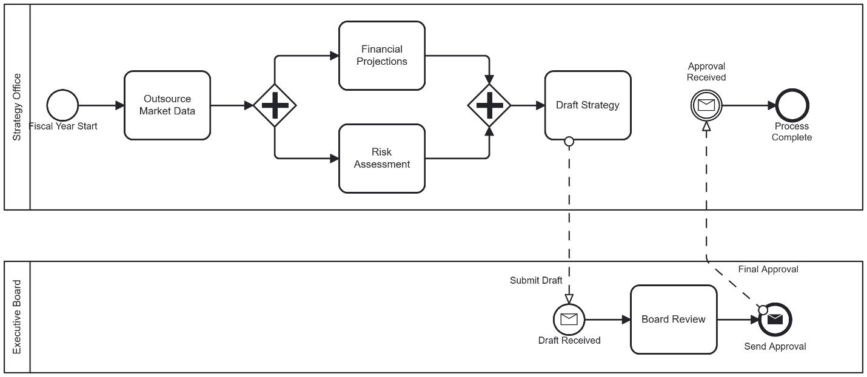

Process 2: Financial Planning

1. Redefine Process (Analysis)
- Identified Waste (Over-processing/Waiting): The "Request for Cuts" loop between Finance and Operational Depts is the biggest waste. It happens because departments submit "Wishlists" instead of realistic budgets.
- Add: Driver-Based Budgeting parameters. Finance sets hard caps before the call.
- Remove: The manual "Consolidate into Master Budget" task. This should be instant via an ERP system.
- Outsourcing: Payroll Calculation. As part of OPEX, payroll complexity is high. Outsource to a provider (e.g., ADP) to feed exact figures into the budget.

2. Redesign Highlights
- Optimization: The "Analyze OPEX" and "Analyze CAPEX" are maintained in parallel (AND gateway) but are now automated system tasks where possible.
- Gateways: Used an Exclusive Gateway (XOR) for the Approval decision.
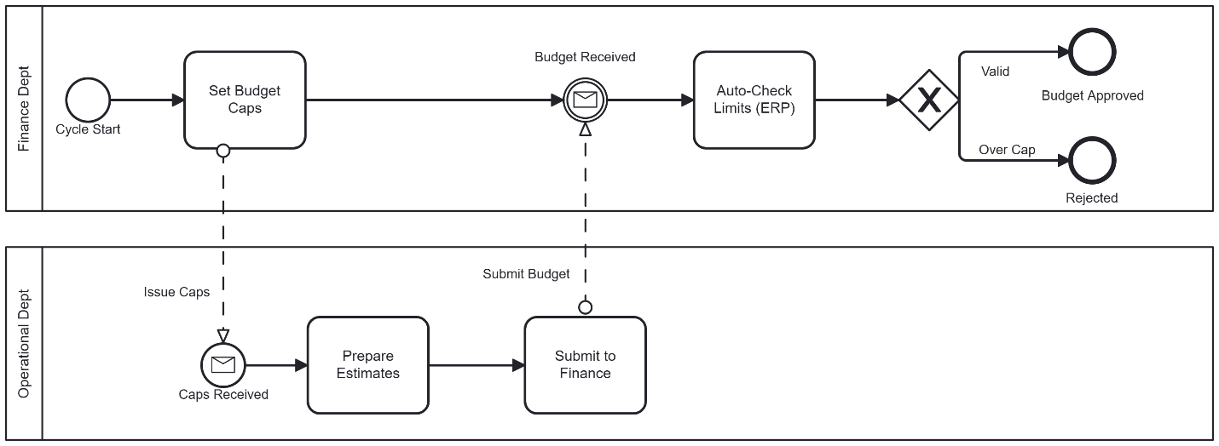

Process 3: Risk Management & Internal Audit

1. Redefine Process (Analysis)
- Identified Waste (Transportation/Motion): The "Engagement Letter" and "Submit Documents" steps are administrative burdens. Waiting for the auditee to "Prepare Evidence" creates a lag.
- Add: Continuous Monitoring. Instead of a "Trigger", the system monitors data 24/7.
- Remove: "Issue Engagement Letter". In an internal audit, access should be mandated by charter, not negotiated per audit.
- Outsourcing: Forensic IT Audit. If a critical risk is found (e.g., cyber breach), outsource the deep-dive investigation to cybersecurity experts.

2. Redesign Highlights
- Shift: From Periodic to Continuous.
- Start Event: Triggered by "Risk Alert" from system, not a calendar date.
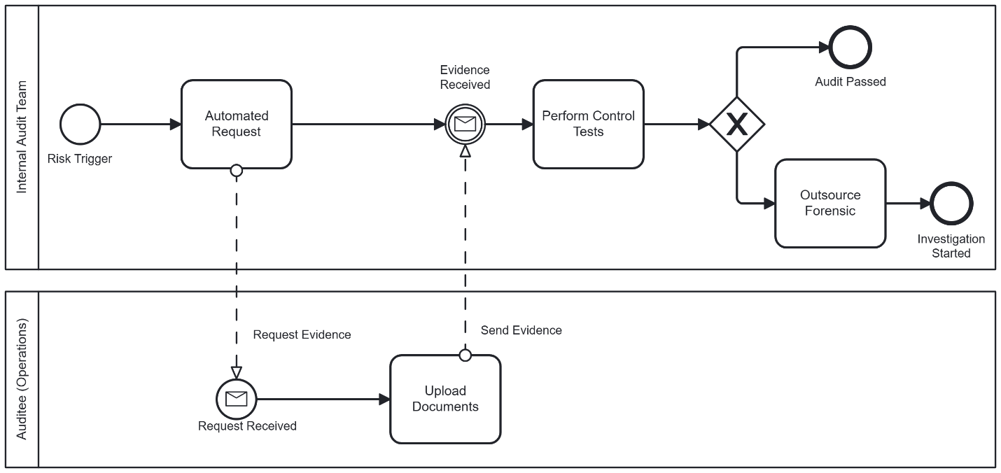

Process 4: Regulatory Compliance

1. Redefine Process (Analysis)
- Identified Waste (Waiting/Talent): The "Research & Interpret Legal Text" is a massive bottleneck. Internal teams may lack specialized knowledge for every new jurisdiction.
- Add: RegTech Integration. Automated feeds that map new laws to existing controls.
- Remove: "Manual Monitoring". Replace with automated control testing.
- Outsourcing: Legal Interpretation. Retain a top-tier law firm for the "Interpretation" phase. The internal team should focus on implementation, not legal theory.

2. Redesign Highlights
- Service Task: "Fetch Regulatory Updates" replaces the manual identification.
- Loop: A simplified loop for implementing controls.
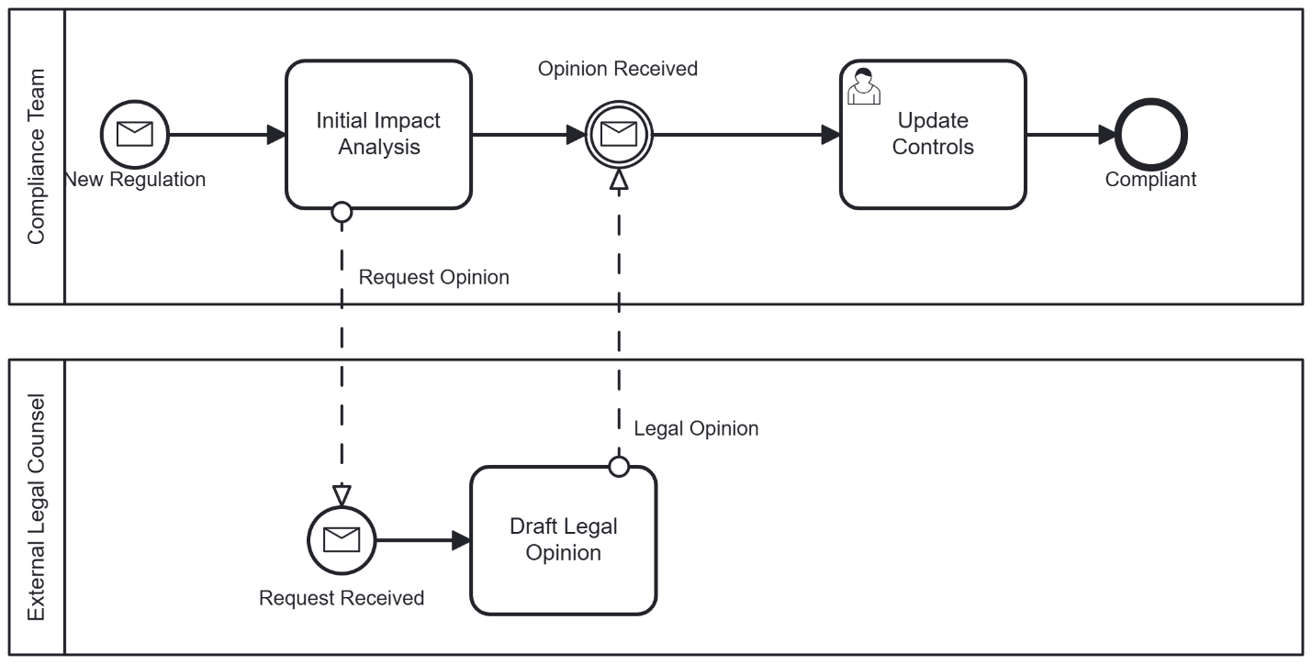

Process 5: Supplier Relationship Management

1. Redefine Process (Analysis)
- Identified Waste (Motion/Defects): The manual "Review Supplier Scorecard" and "Negotiate Terms" every cycle is inefficient. "Inspect Incoming Goods" is a duplicate effort if the supplier is trusted.
- Add: Vendor Portal. Suppliers upload their own compliance data.
- Remove: Routine Inspection. For "Gold Tier" suppliers, remove the "Inspect Incoming Goods" step and move to random sampling.
- Outsourcing: Logistics/Transportation. The "Deliver Goods" phase should be handled by a 3PL (Third Party Logistics) provider to optimize routes and costs.

2. Redesign Highlights
- Automation: The "Scorecard" is calculated automatically by the ERP based on delivery time and defect rates.
- Logic: A gateway checks "Supplier Tier". Gold tier skips inspection.
